
Official league roster – Basketball 2023-24
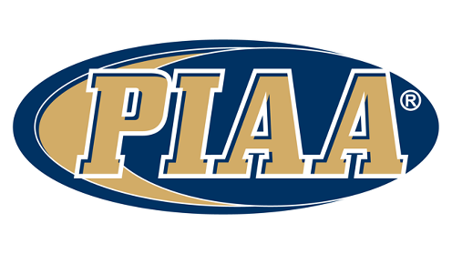
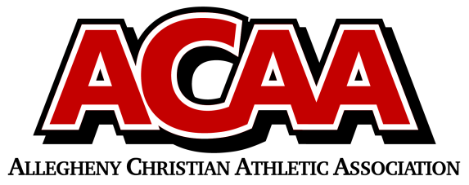

School Name: Meadowbrook Christian
Team Colors: Forest Green / White
Overall Wins ___ Losses ____ Ties ___
ACAA Wins ___ Losses ____ Ties ___ OPPONENT: __________________________
Date: _________

Number | Name | Year |  | Position | Height | Homeschool
25 | Grace Ask | 12th
14 | Maddy Fasnacht(Faus-not) | 12th
34 | Faith Lubold | 11th
12 | Chloe Miller | 11th
22 | Lauren Dugan | 10th
20 | Ally Fisher | 10th
24 | Megan Reed | 10th
15 | Kaylee Ward | 10th
3 | Leila Ask | 9th
11/23 | Addisyn Wolfe | 9th

VARSITY/JV GIRLS
Head Coach: Shane Devlin
Asst. coach: Amy Fasnacht and Ryan Torrey
Athletic Director: Samantha Erb
Statistician: Brynn Rhoades and
Sheri Hoffman

Official ACAA League Team Roster. to be submitted to the scorer’s table before each game.

